Project Management Essentials: Structured Delivery for Business Results
Plan with Clarity. Execute with Discipline. Deliver with Confidence

SYNOPSIS
Projects rarely fail because of a lack of effort.
They fail because of unclear scope, poor planning, weak coordination, and uncontrolled change.
Deadlines slip. Costs escalate. Stakeholders lose confidence—not because teams are incapable, but because execution lacks structure and control.
This workshop equips participants with a disciplined, end-to-end approach to managing projects using structured project management principles. It focuses on clarity upfront, control during execution, and accountability throughout the lifecycle.
Participants will learn how to:
- Define projects with precision
- Plan tasks, timelines, and resources effectively
- Manage risks, stakeholders, and changes
- Track progress and ensure delivery
This is about structured execution in environments where predictability, governance, and control matter.
By the end of the workshop, participants will be equipped to plan and deliver projects with confidence, consistency, and measurable outcomes.
Why Now?
Organizations are under increasing pressure to deliver:
- Projects faster
- With fewer resources
- Under tighter scrutiny
At the same time:
- Stakeholders demand clarity and accountability
- Projects involve multiple functions and dependencies
- Poor planning leads to rework and delays
Without structured project management:
- Scope expands uncontrollably
- Risks are identified too late
- Communication breaks down
- Delivery becomes reactive instead of planned
This workshop enables participants to:
- Bring structure and discipline into project execution
- Improve planning, accuracy and coordination
- Enhance stakeholder confidence
- Deliver projects on time, within scope, and with expected quality

OBJECTIVES
By the end of this workshop, participants will be able to:
- Describe key principles and phases of structured project management
- Explain the importance of scope, time, cost, and quality constraints
- Apply tools such as Work Breakdown Structure (WBS) and project scheduling
- Analyze project risks and dependencies
- Evaluate trade-offs in project decisions (time vs cost vs scope)
- Develop comprehensive project plans
- Construct stakeholder communication strategies
- Formulate monitoring and control mechanisms for project delivery

OUTLINE

Day 1: Building the Foundation for Structured Project Delivery
1. Understanding Project Management Fundamentals
- What defines a project
- Project lifecycle (Initiation → Planning → Execution → Closure)
- Role of the project manager
2. Defining Scope Clearly
- Project objectives and deliverables
- Scope statements vs assumptions
- Avoiding scope creep
3. Planning the Project
- Work Breakdown Structure (WBS)
- Task sequencing and dependencies
- Estimating time and resources
4. Developing the Project Schedule
- Gantt charts and timelines
- Critical path concept (intuitive understanding)
- Identifying bottlenecks
Day 2: Managing Execution and Ensuring Delivery
5. Managing Risks and Issues
- Identifying potential risks early
- Risk assessment and mitigation strategies
- Issue tracking and resolution
6. Stakeholder Management and Communication
- Identifying stakeholders
- Managing expectations
- Structuring communication for clarity
7. Monitoring and Controlling Projects
- Tracking progress against plan
- Managing deviations
- Change control process
8. Project Closure and Learning
- Delivering outcomes and handovers
- Post-project review
- Capturing lessons learned
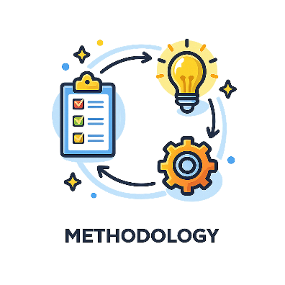
METHODOLOGY:
This workshop is practical, structured, and execution-focused:
- Case-Based Learning
Participants work through realistic project scenarios
- Hands-On Planning Exercises
Building WBS, schedules, and risk plans
- Group-Based Activities
Simulating project coordination and decision-making
- Facilitated Discussions
Linking concepts to real workplace challenges
- Application-Focused Learning
Immediate relevance to participants’ current or upcoming projects
WHO SHOULD ATTEND:
This workshop is specifically designed for professionals, frontline staff and other office personnels who are responsible for planning, coordinating, or delivering projects:
- Project coordinators and project managers
- Team leaders and supervisors
- Professionals involved in project work across functions
- Individuals new to structured project management
- Anyone tasked with delivering outcomes within timelines and constraints
No prior knowledge of Agile or formal project management frameworks is required.
If your role involves managing timelines, coordinating tasks, or delivering outcomes this workshop is relevant.

DURATION:
1 Day
- Fully Instructor-led
- Includes hands-on exercises and applied learning

